Step 1: First, install Java Development Kit (JDK) from <https://www.oracle.com/java/technologies/downloads/>. Then proceed the installation procedure.

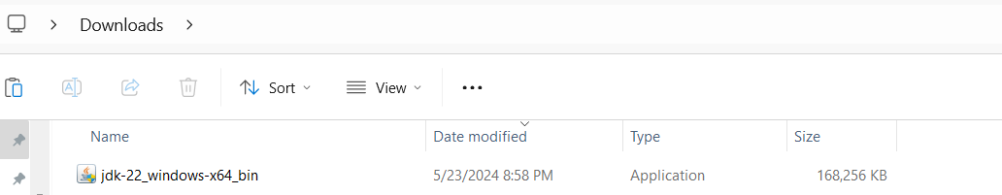

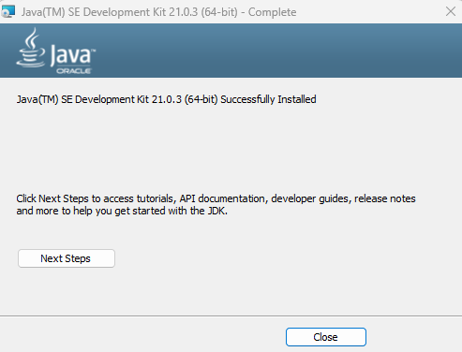

Step 2: Now, setup environment variables and set the path where JDK is installed and click OK.

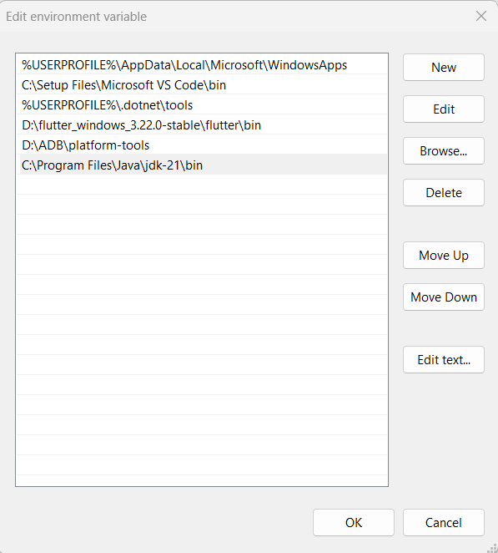

Step 4: Now, download the latest version of Android Studio from https://developer.android.com/studio.

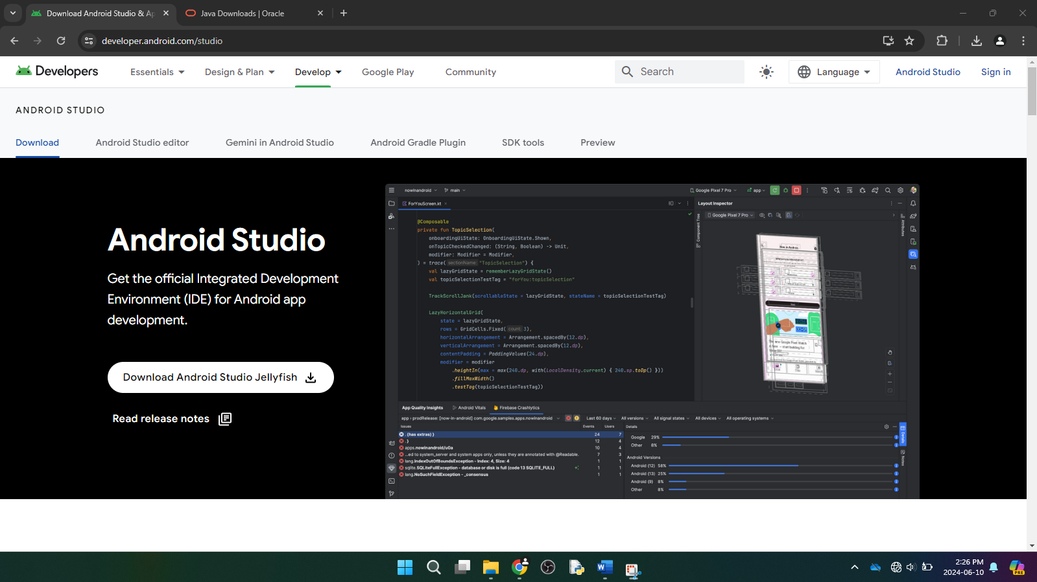

Step 5: We should agree the terms and conditions and click on Next until the Install button appears and Click on Install.

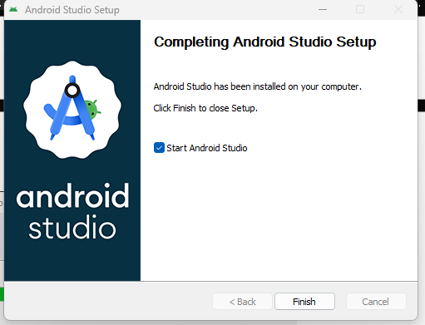

Step 6: After installation, following window appears.

Step 7: Then, choose the type of setup for Android Studio, click Next and click Accept to accept the license agreement.

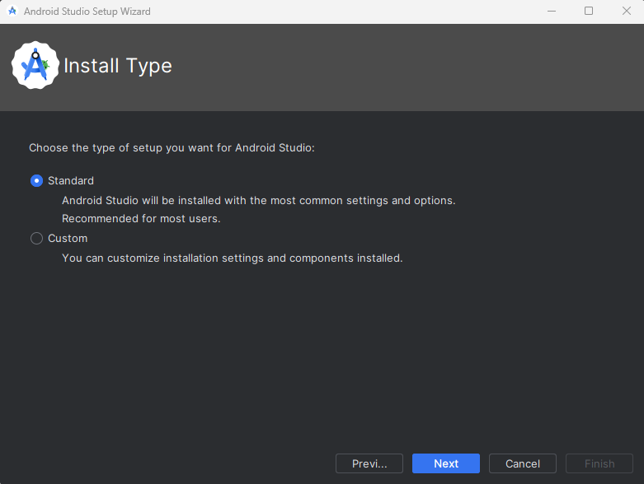

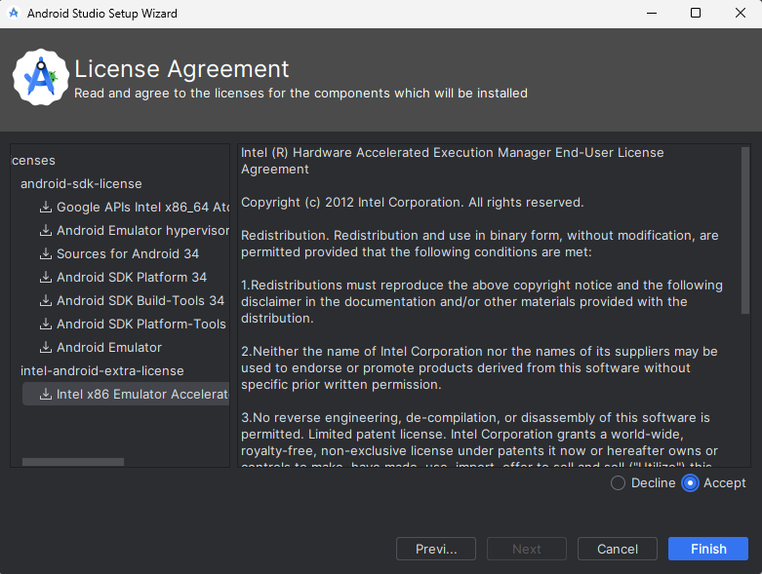

Step 8: Launch the application.

Step 9: Click on No Activity and Next to create a new project.

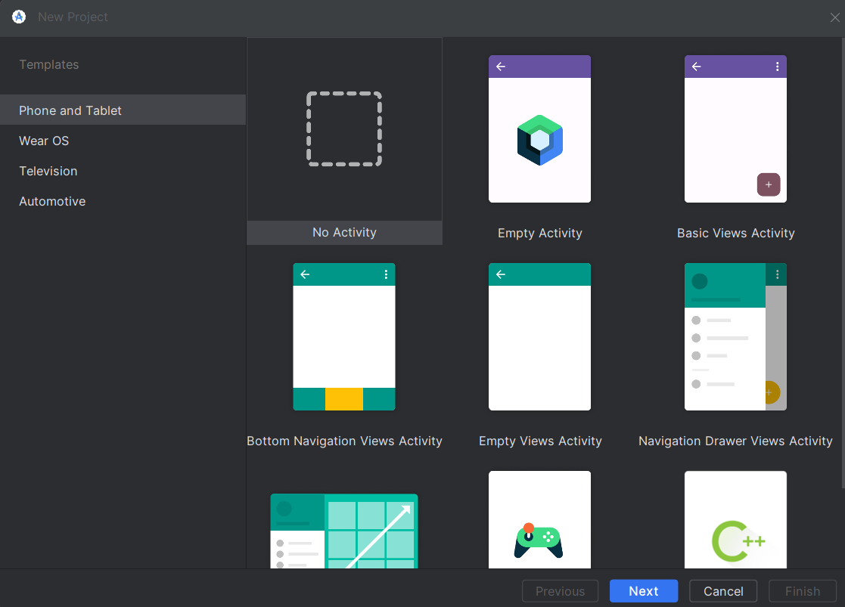

Step 10: Give the appropriate name, package name, location to be saved, language, minimum SDK, build configuration language and click on Finish.

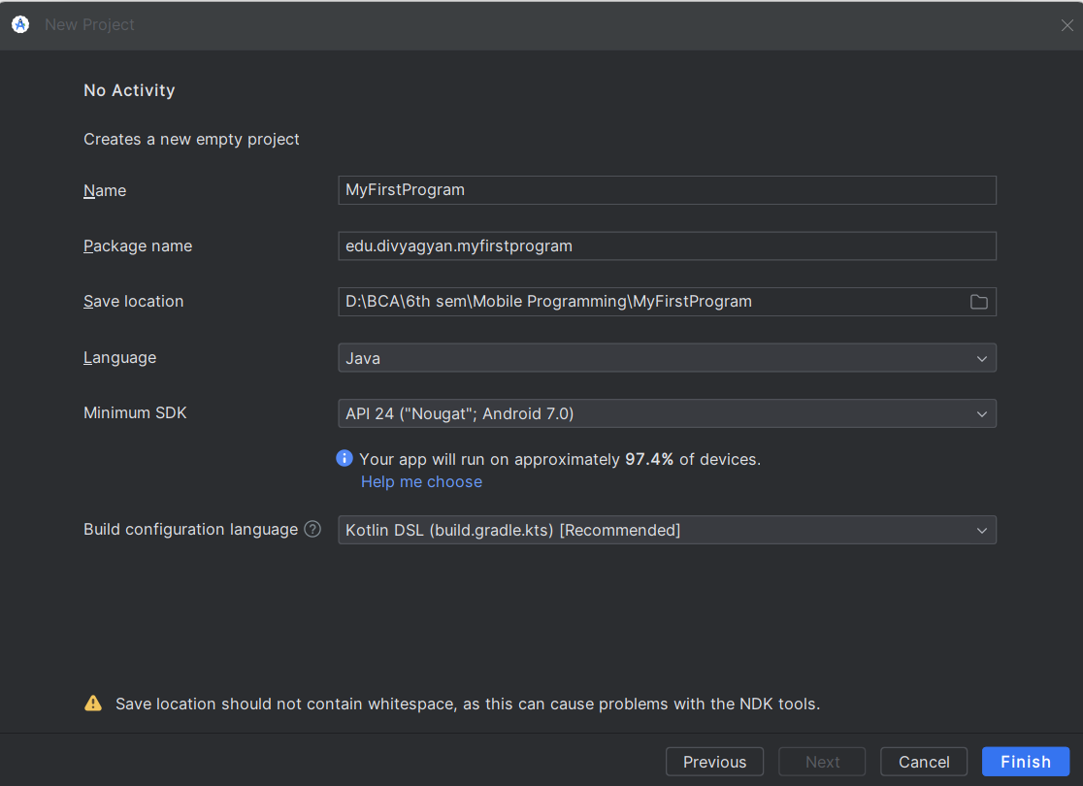

Step 10: Then go to settings and configure SDK Platforms and SDK Tools.

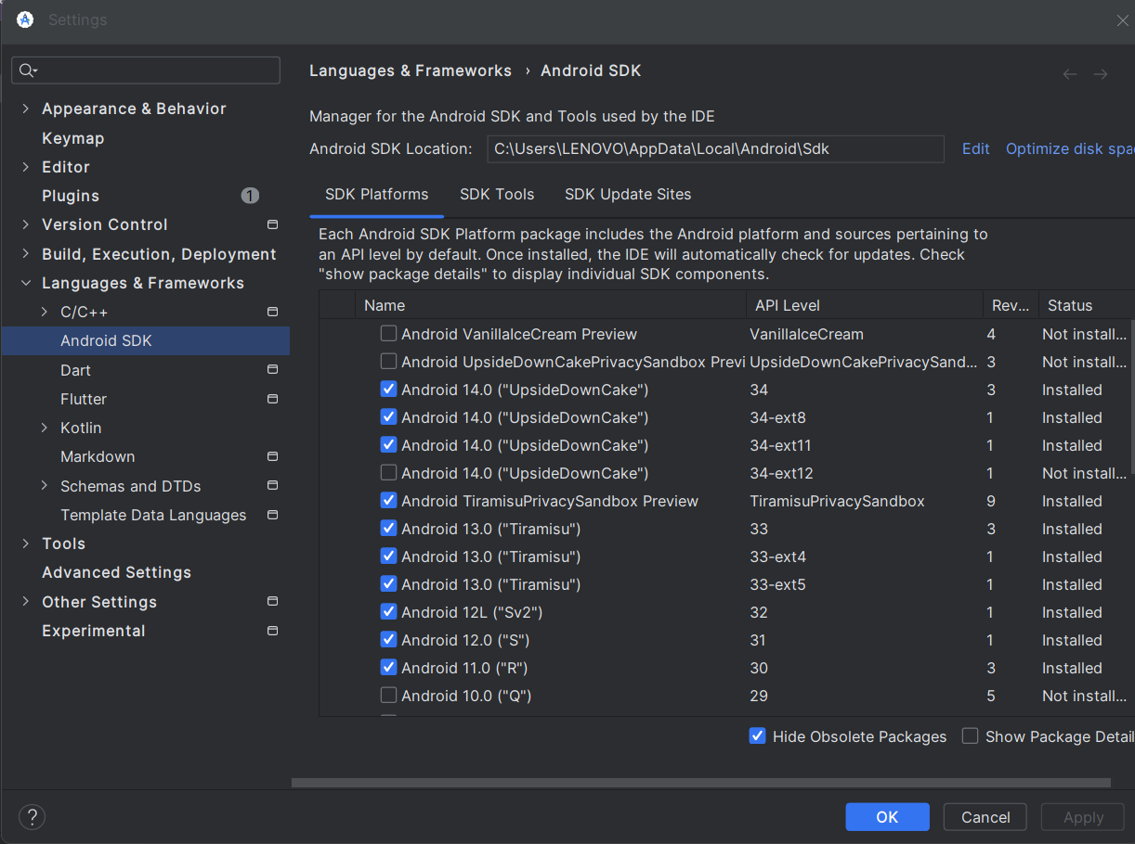

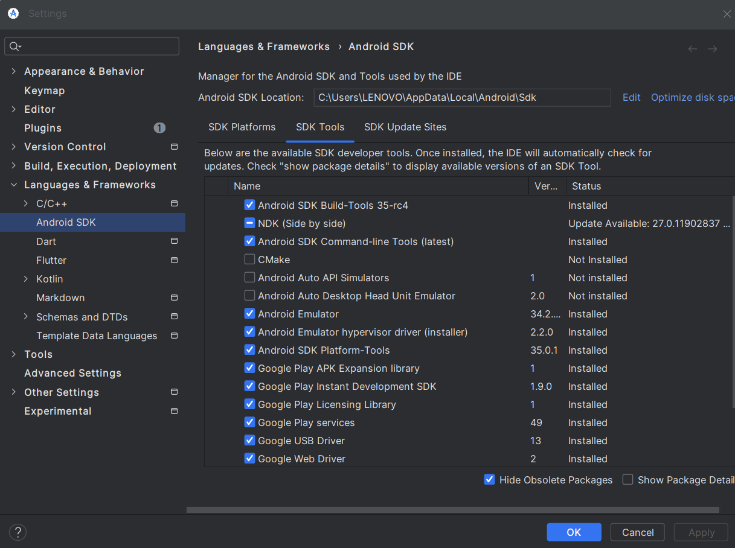

Step 11: Open the Device Manager by clicking Tools > Device Manager.

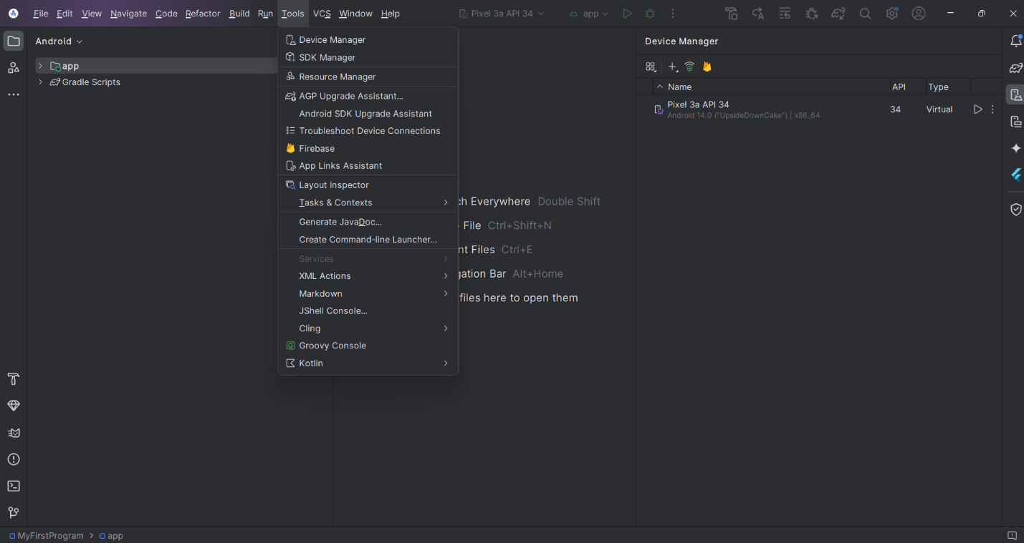

Step 12: Click on add icon and then on Create Virtual Device.

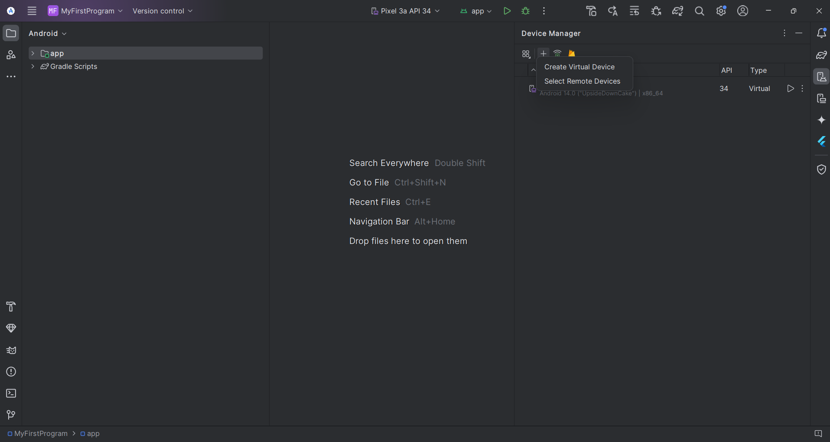

Step 13: Select a hardware profile and then click Next.

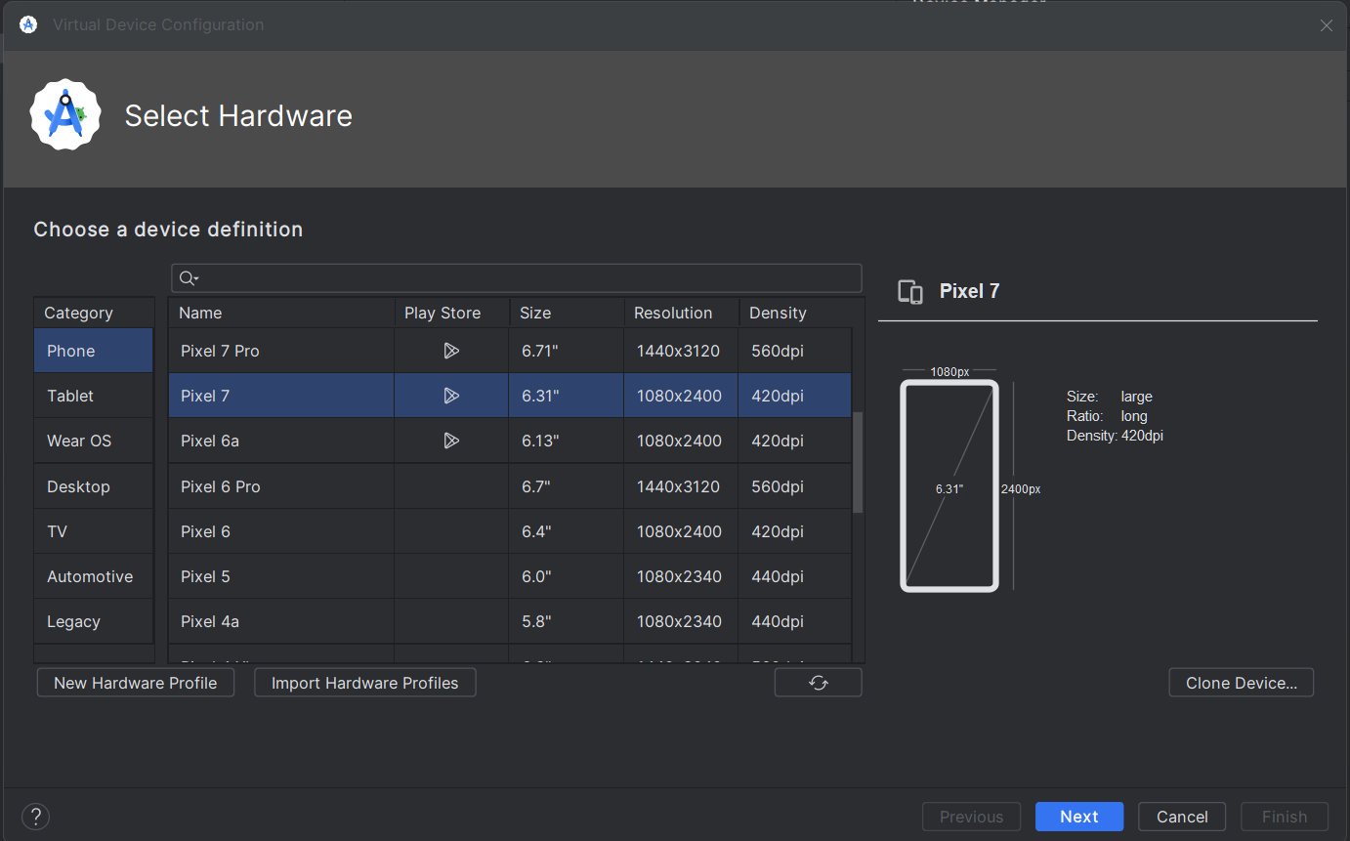

Step 14: Select a system image and then click Next.

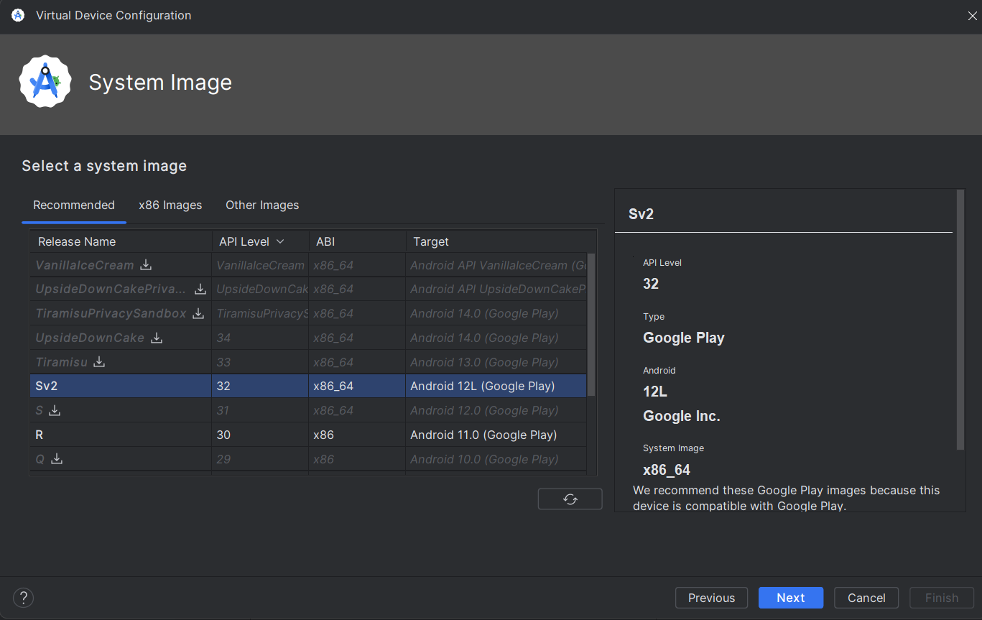

Step 15: Change AVD properties if needed, and then click Finish. The virtual device is then created.

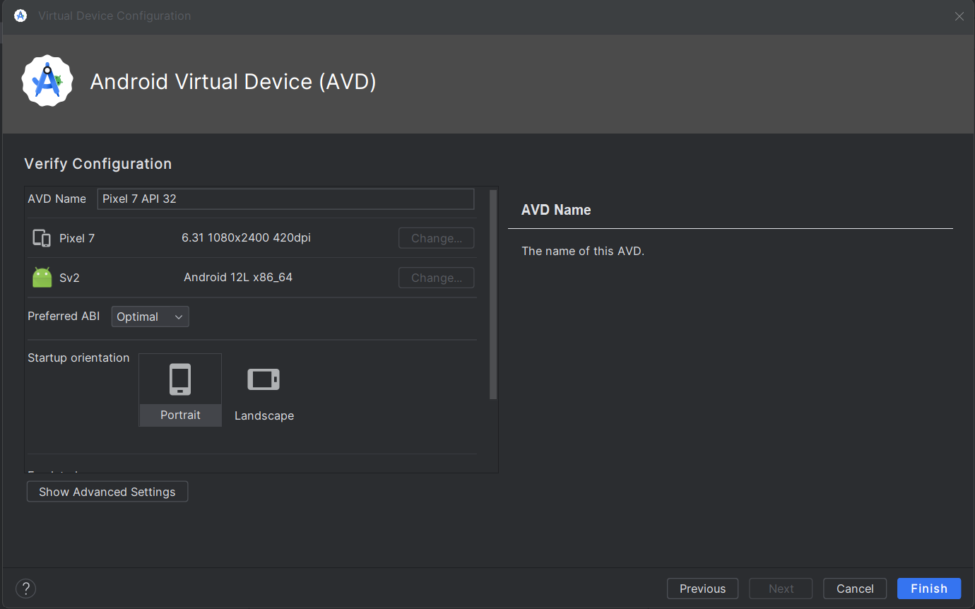

Steps for running application on an emulator:

Step 1: In the toolbar, choose the AVD to run our app from the target device from the drop-down menu.

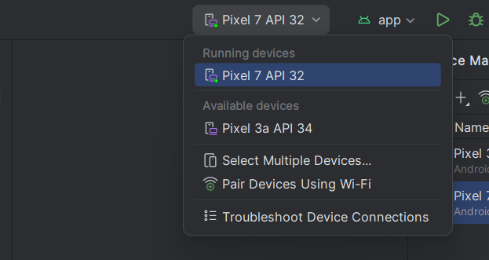

Step 2: Click Run. Finally, our virtual device is ready to run our android app.

